Group A
1. Given the following Java program:
import java.util.*;
public class Main {
public static void main(String[] args) {
List num = new ArrayList(Arrays.asList(23, 16, 14, 33, 19, 6, 1));
System.out.println("List is "+num);
}
}
- Give the index values of all the odd numbers assuming zero-based indexing

ANSWER:
Odd numbers in array | Index
23 | 0
33 | 3
19 | 4
1 | 6
- How many elements would be looked at when the list is traversed (from start to finish) until the value 19 was found?

ANSWER:
When the list in the program is traversed, 5 elements in the array
will be looked at.

2. Which of the following lists are syntactically correct in Java?
- List num = new ArrayList(Arrays.asList(1, 2, 3, 'four'));

ANSWER:
No.
Firstly, multiple characters or the string cannot be within single quotes. Strings are inside double quotes.
And, the ArrayList object needs to have similar datatype inside. If the above statement tried to compiled, it will have a compilation error telling that the ArrayList cannot be resolved to a datatype.

- List num = new ArrayList(Arrays.asList(1, 2, [3, 4]));

ANSWER:
The statement results in error. Because the syntax of defining array directly with the big brackets [] is not supported by java.

And even if there was correct syntax of array in that parameters,
the asList method expects the arguments to be of similar data type which is not in this example. They are of type int and int[].

3. Perform a series of list operations on the following list:
List fruit = new ArrayList (Arrays.asList('apple', 'banana', 'pear', 'cherry'));
to produce this updated list:
['Grapefruit', 'banana', 'Date', 'cherry', 'Orange']
ANSWER:

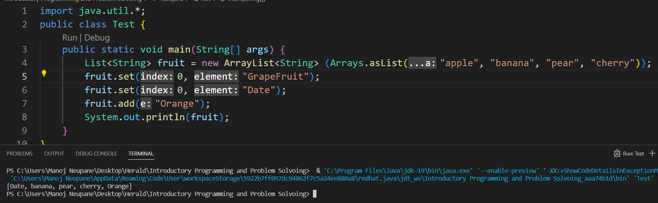

Group B
- Find in array.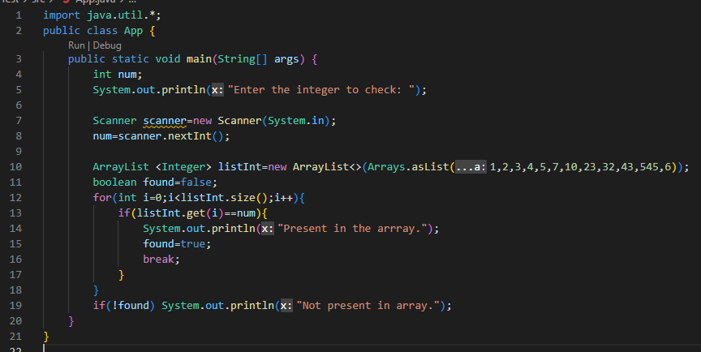

- Average
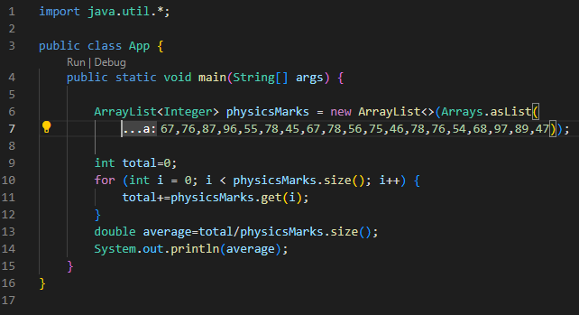

- Reverse array.
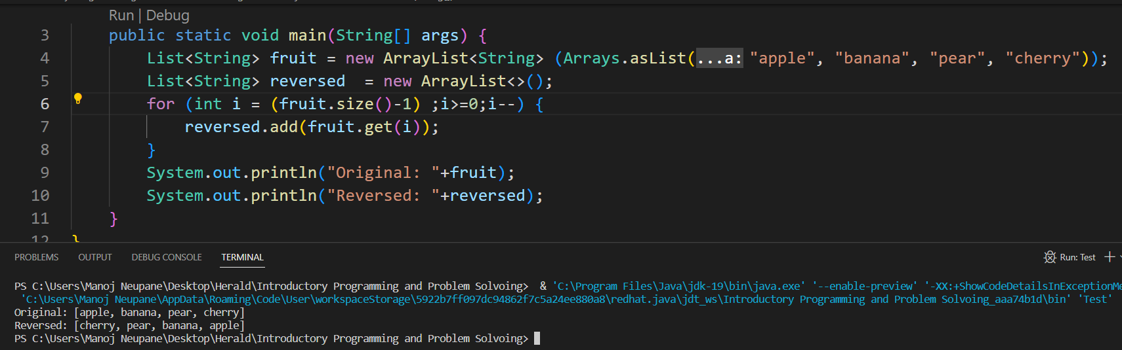

- Find max in array.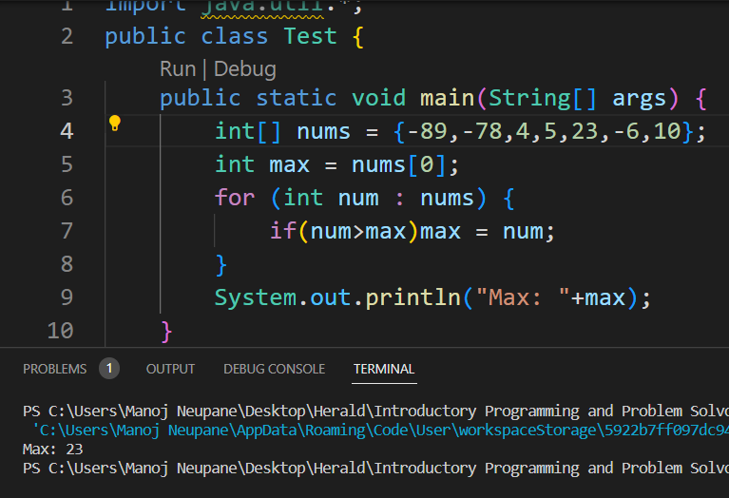

- Check if array is sorted.
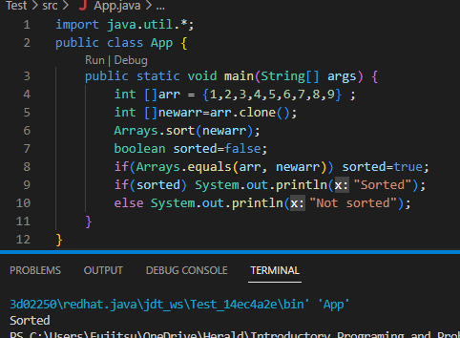

Group C
- Append to the end of hashset.
Since, HashSet class doesn’t assure element synchronization, it cannot be guaranteed that element added goes to the last.
But hashtable is synchronized, so it can be done in hashtable.
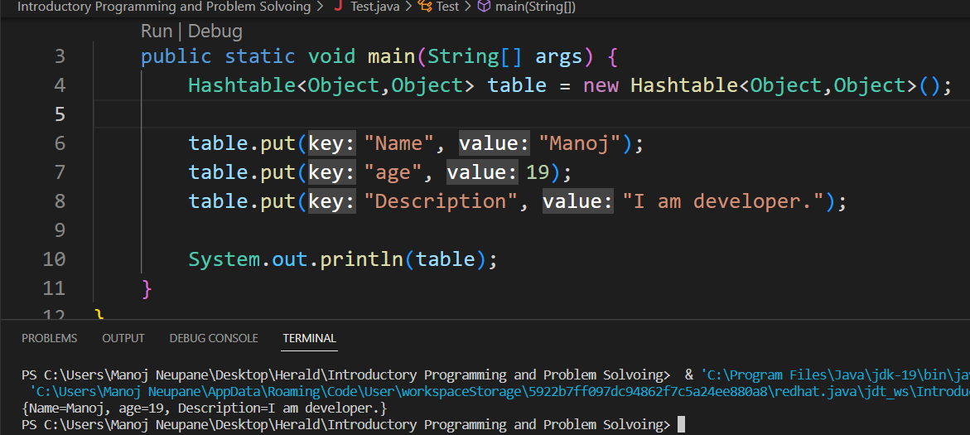
- Java set intersection.
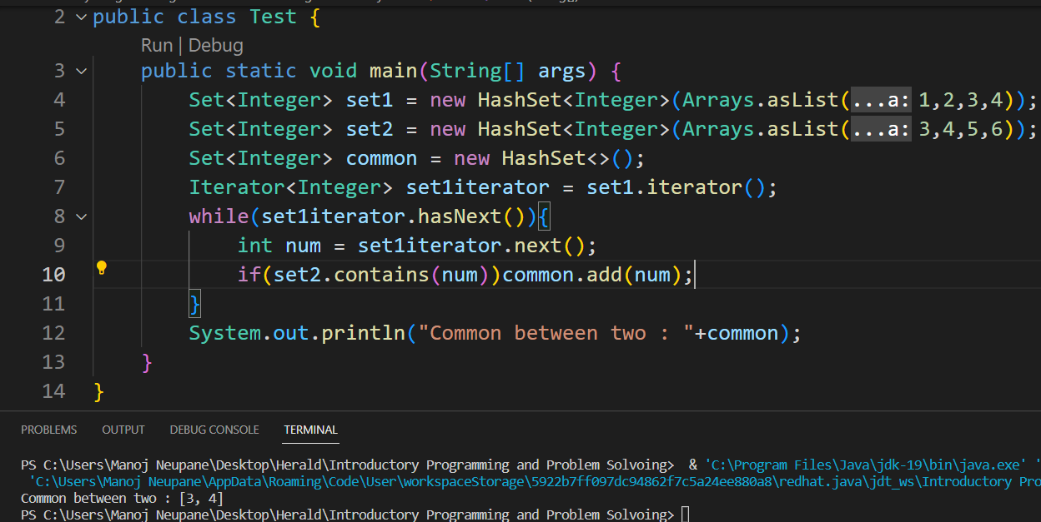
- Count pairs in hastable.
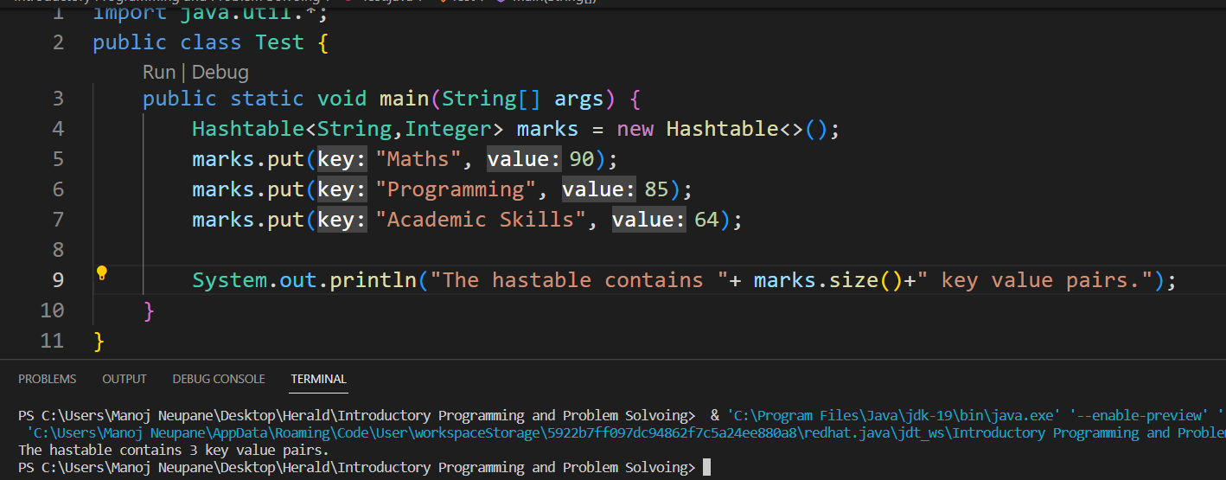
- Collection view of map.
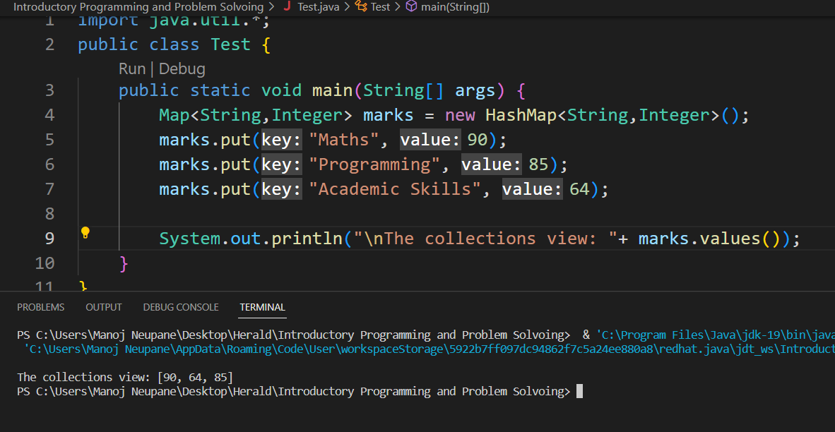

Group D
- Rock Paper Scissors.
Ask the user to enter in their move.
Make a list of valid moves.
Check if the user entered a valid move by looking at the list of valid moves. (If the move is in the list, it is valid move)
Randomly generate the opponent’s move. (Randomly choose one move from the list of valid moves)
Display the result to user
Use a loop to continue asking the user for their move.
Check if the user wants to quit.
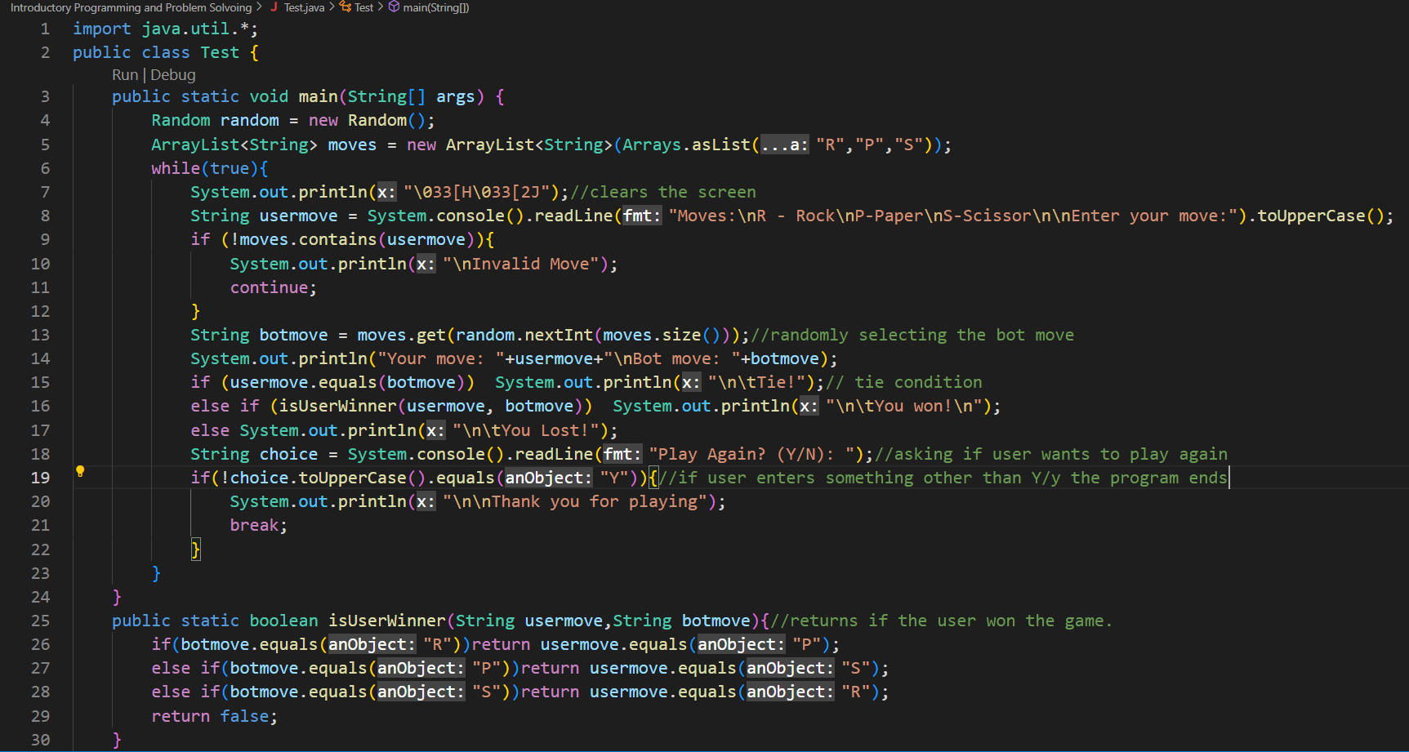

Gameplay:
